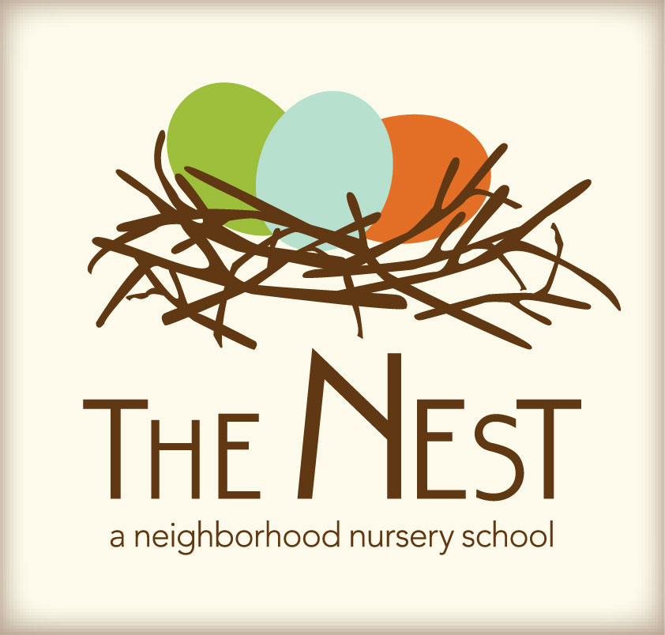 Menu – September 21 - 25

 | Monday  September 21 | Tuesday  September 22 | Wednesday  September 23 | Thursday  September 24 | Friday  September 25
Morning Snack | Cinnamon toast  Prunes  Water | Scrambled eggs  Raisins  Water | Waffles  Blueberries  Water | Oatmeal with pears  Craisins  Water | Bagels with bream cheese  Bananas  Water
Lunch | Cheese tortellini  Green peas  Tossed salad  Multi grain bread  Milk | Tomato risotto  Roasted kale  Orange slices  Yeast rolls  Milk | Veggie and cheese wraps  Black bean and quinoa casseroles  Avocado slices  Milk | Mushroom barley soup  Spinach/strawberry salad  Naan bread  Milk | Baked potato with the fixings  Steamed broccoli  Pears  Milk
Afternoon Snack | Graham crackers  Sunbutter  Water | Pretzels  Strawberries  Water | Cereal trail mix  Dried fruit  Water | Sweet peppers  Hummus  Water | Warm pita bread  Goat cheese  Water

