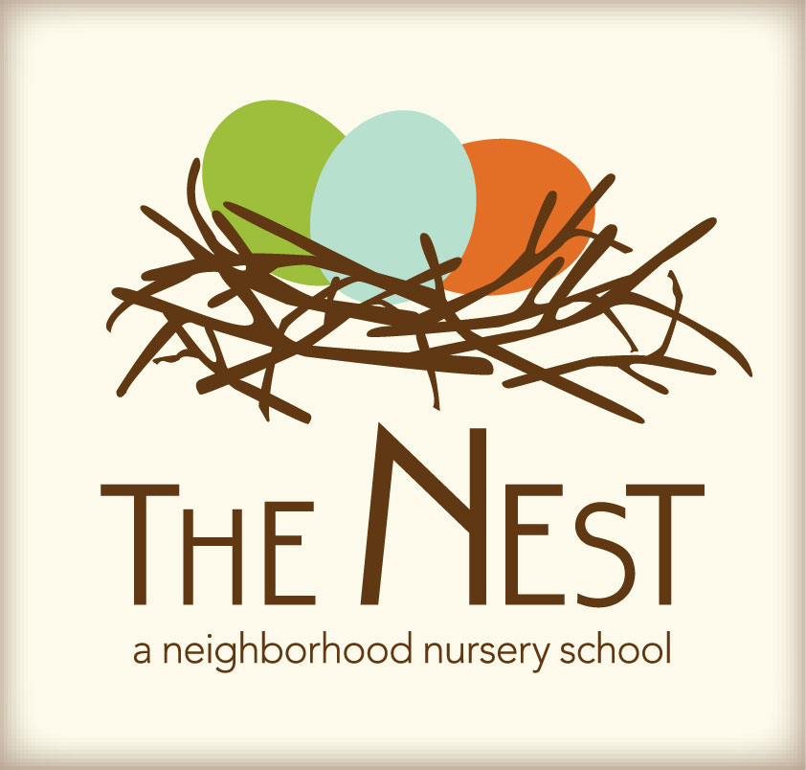 Menu – November 10- 14

 | Monday  November 10 | Tuesday  November 11 | Wednesday  November 12 | Thursday  November 13 | Friday  November 14
Morning Snack | Pumpkin and blueberry muffins  Sliced bananas and oranges  Water | Banana yogurt with raisins and oranges  Water | Cheese grits  Grapes  Water | Sour cream pancakes  Blueberries  Water | Buttered toast/apricot preserves  Cheese slices  Water
Lunch | Roasted red pepper feta sauce with fettuccine  Fruit salad  Wheat rolls  Milk | Broccoli and cheddar soup  Soup crackers  Mixed green salad with Italian dressing  Milk | Black beans  Rice  Steamed carrots  Mango/avocado salad  Cinnamon tortillas  Milk | Baked sweet potatoes  Turnip greens  Asian pears  Milk | Sunbutter and jelly sandwiches  Pretzels  Carrots and celery sticks  Milk
Afternoon Snack | Wheat crackers with sun butter  Oranges  Water | Hummus with warm pita bread  Baby carrots  Water | Rice cakes with sun butter  Raisins  Water | Roasted chickpeas  Crackers  Cheese cubes  Water | Wheat crackers  Cheese sticks  Apple slices  Water

