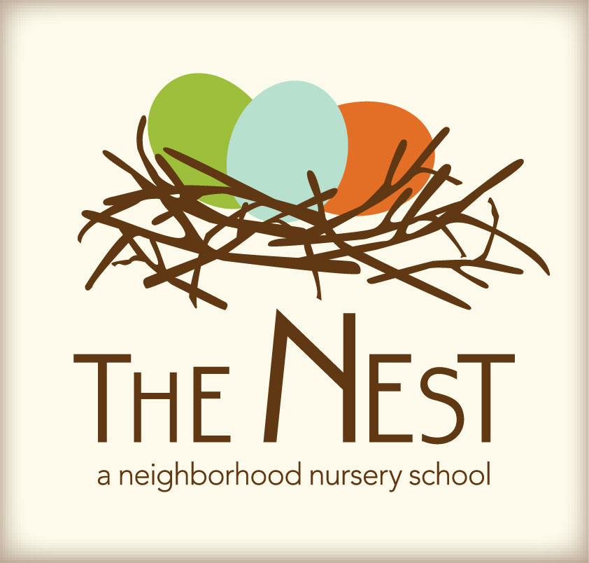 Menu – June 27-July 1st

 | Monday  June 27 | Tuesday  June 28 | WACKY Wednesday  June 29 | Thursday  June 30 | Friday  July 1st
Morning Snack | Whole Grain Cereal  Bananas & Cantaloupe  Water | Scrambled Eggs  Cheese Triangles  Strawberries  Water | Chocolate Chip Pancakes  Orange Slices  Water | Oatmeal w/blueberries  Sun butter & Honey Tortilla Triangles  Water | Pancakes  Hard Boiled Egg  Mixed Fruit  Water
Lunch | Stir Fry Sesame Carrots & Broccoli & Squash  Whole Grain Rolls  Milk | Cream Cheese & Cucumber Sandwiches  Vegetable Alphabet Soup  Milk | Wacky Mac-N-Cheese, Stir Fry Veggies, Soup  Mixed Fruit  Milk | Mexican Casserole  Sliced Avocados  Chopped Salad  Milk | Pasta Puttanesca  Roasted Green Beans  Milk
Afternoon Snack | Carrots & Cucumbers w/ranch  Dried Fruit  Water | Cheese & Crackers  Cantaloupe  Water | Wacky Smiley Face Rice Cakes w/ Sun butter & Dried Cranberries | Edamame  String Cheese  Water | Sliced Peppers &  Pretzel Sticks w/Hummus  Water

