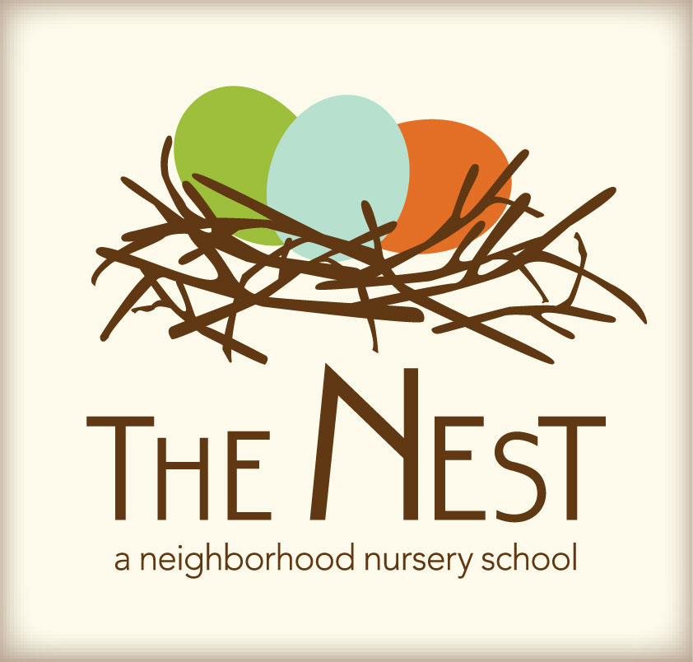 Menu – June 20-24

 | Monday  June 20 | Tuesday  June 21 | WACKY Wednesday  June 22 | Thursday  June 23 | Friday  June 24
Morning Snack | English Muffins w/ Cream Cheese & Preserves  Water | Whole Grain Cereal  Strawberries  Water | Egg & Tomato Frittata  Pears  Water | Oatmeal w/cherries  Sun butter & Honey Tortilla Triangles  Water | Pancakes  Hard Boiled Egg  Mixed Fruit  Water
Lunch | Black Beans  Yellow Rice  Roasted Kale  Cheese Triangles  Milk | Summer Squash & Corn Chowder  Garlic Bread Sticks  Honey Dew Melon  Milk | Wacky Mac-N-Cheese, Roasted Kale, Black Beans, Rice, Corn Chowder  Milk | 3 Pepper & Cheese Lasagna  Peas  Milk | Lemon & Herb Orzo Salad  Roasted Chick Peas  Pita Bread  Milk
Afternoon Snack | Carrots & Celery w/ranch  Dried Fruit  Water | Cheese & Crackers  Honey Dew Melon  Water | Wacky Ants on a Log: Celery, Raisins, Sun butter  Water | Edamame  String Cheese  Water | Sliced Peppers &  Pretzel Sticks w/Hummus  Water

