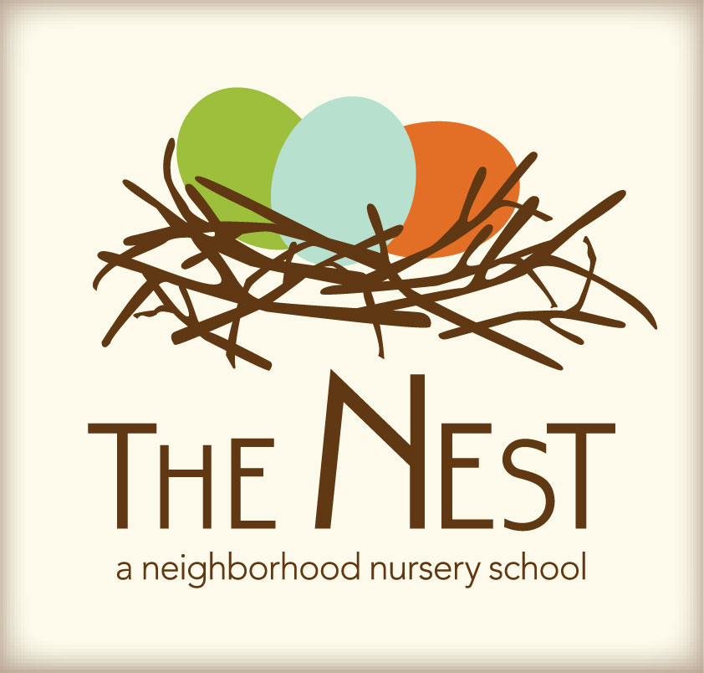 Menu – June 13-17

 | Monday  June 13 | Tuesday  June 14 | WACKY Wednesday  June 15 | Thursday  June 16 | Friday  June 17
Morning Snack | Cheese Grits  Apple Slices  Water | Whole Grain Cereal  Dried Plums  Bananas  Water | Scrambled Eggs w/Herbs  Pears  Water | Oatmeal w/cranberries  Sun butter & Honey Tortilla Triangles  Water | Pancakes  Hard Boiled Egg  Peaches  Water
Lunch | Sunbutter & Jelly Sandwiches  Homemade Tomato Basil Soup  Milk | Lentils  Arboro Rice  Carrots & Peas  Garlic Bread  Milk | Wacky Mac-N-Cheese, lentils, Rice, Tomato Soup, Stir Fry snow peas & carrots, Oatmeal Cranberries  Milk | Spinach Butter & Herb Pasta  Roasted corn on the cob  Milk | Red bean & Cheese Quesadilla  Roasted Green Beans  Milk
Afternoon Snack | Apple Grape Salad  Pretzels  Water | Grape Tomatoes & Cucumbers w/ranch  Cheese cubes  Water | Wacky Mixed Fruit  Oyster crackers  Water | Orange Blossom Muffins  Raisins  Water | Sliced Peppers Hummus  Water

